HIGH LEVEL DESIGN(HLD)

FLIGHT FARE ESTIMATOR

Revision Number:1.0

Last date of revision:25/10/2021

Table of Contents

1 Document Version Control 4

2 Abstract 5

3. Introduction 6

3.1 Why this High-Level Design? 6

4.General Description 6

4.1 Product Perspective 6

4.2 Problem Statement 6

4.3 Proposed Solution 6

4.4 Technical Requirements 7

4.5 Data Requirements 7

4.6 Tools Used 8

4.7 Constraints 9

4.8 Assumptions 9

5. Design Details 10

5.1 For Training 10

5.2 Deployment process 11

5.3 Event Log 11

5.4 Error Handling 11

6. Performance 12

6.1 Reusability 12

6.2 Application Compatibility 12

6.3 Resource Utilization 12

6.4 Deployment 12

6.5 User Interface 14

7. Conclusion 14

# 1 Document Version Control

|  |  |  |  |
| --- | --- | --- | --- |
| Date Issued | Version | Description | Author |
| 25/10/2021 | 1.0 | Initial HLD | Suraj Joshi |
|  |  |  |  |
|  |  |  |  |
|  |  |  |  |
|  |  |  |  |
|  |  |  |  |
|  |  |  |  |

# 2 Abstract

There are many ways through which we travel from one place to another but now days traveling through flight is more preferred way by peoples due to its less travelling time. Due to such a high demand in traveling, flight tickets price changing continuously. Though there are many other factors on which flight fare depends on like flight timing, source and destination of the flights, it depends upon festive or holidays season and more like this. Airlines company have different kind of computational techniques through which they can maintain their revenues but when it comes to customer, they don’t have any technique by which they estimate the flight fare so they can plan their journey in advance. Because of this I’m building some prediction model using different regression algorithms through which travellers will get an idea of the flight fare, so that they can plan their journey in prior.

# 3. Introduction

## 3.1 Why this High-Level Design?

The purpose of this High-Level Design (HLD) Document is to add the important details about this project. Through this HLD Document, I’m going to describe every small and big-things about this project.

# 4.General Description

## 4.1 Product Perspective

The Flight Fare Prediction predict the flight price using regression based Machine Learning algorithm that is XGBRegressor.

## 4.2 Problem Statement

Traveling through flights has become an integral part of today's lifestyle as more and more people are opting for faster traveling options. The flight ticket prices increase or decrease every now and then depending on various factors like timing of the flights, destination, and duration of flights various occasions such as vacations or festive season. Therefore, having some basic idea of the flight fares before planning the trip will surely help many people save money and time. The main goal is to predict the fares of the flights based on different factors available in the provided dataset.

## 4.3 Proposed Solution

The solution is to build a machine learning algorithm which will be able to predict the fare prices. We have many Regression based algorithm like Linear Regression,Decision tree regressor,Random forest regressor,XGBRegrssor etc.We are going to pick up only XGBRegressor because of its good performance.But before that we are going to preprocess the raw data provided by our client and then the model building process will come.

## 4.4 Technical Requirements

In this project we are having a set of requirements and they are given below

a) Model should be exposed through API or User Interface, so that anyone can test model.

b) Model should be deployed on cloud (Azure, AWS, GCP).

c) Cassandra database should be integrated in this project for any kind of user input.

## 4.5 Data Requirements

Data Requirement completely depend on our problem.

a) For training and testing the model, we are using flight fare prediction dataset from Kaggle .

b) From user we are taking following inputs:

→ Airlines Service – It can be

'Multiple carriers' ,'Air Asia' ,'Jet Airways' ,'IndiGo', 'Air India',

'Vistara', 'SpiceJet' ,'GoAir', 'Jet Airways Business',

'Multiple carriers Premium economy', 'Vistara Premium economy', 'Trujet' etc

→ Date of Journey in the format of dd/mm/yyyy.

→ Source - Banglore, Kolkata,New Delhi, Chennai, Mumbai.

→ Destination – New Delhi, Banglore, Cochin, Kolkata, Hyderabad.

→ Route – DEL →BOM → COK

→ Dep_Time – hh:mm h is hour and m is minute

→ Arrival_Time – hh:mm dd Month(name)

→ Duration – Data should be in this format 10h 55m or 4h

→ Total Stops – non-stop, 1 stop, 2 stops ,3 stops, 4 stops.

→ Additional_Info – It can be

'No Info', 'No check-in baggage included', 'In-flight meal not included',

'Business class', '1 Long layover', 'Change airports' ,'Red-eye flight',

'1 Short layover', '2 Long layover'.

## 4.6 Tools Used





********

→ PyCharm is used as IDE.

→ For visualization of the plots, Matplotlib, Seaborn are used.

→ Heroku is used for deployment of the model.

→ Cassandra is used to retrieve, insert, delete, and update the database.

→ Front end development is done using HTML/CSS, Flask is used for backend development and for API development.

→ GitHub is used as version control system.

## 4.7 Constraints

The Flight fare prediction system must be user friendly, errors free and users should not be required to know any of the back-end working.

## 4.8 Assumptions

It is assumed that all the aspect of this project have the ability to work together in the way designer is expecting.

# 5. Design Details

## 5.1 For Training

DATA COLLECTION

DATA VALIDATION

HYPERAMETER TUNING

MODEL SELECTION

DATA PREPROCESSING

DB OPERATIONS

SAVING MODEL

## 5.2 Deployment process

DATA COLLECTION

DATA VALIDATION

MODE LOADING

DATA PREPROCESSING

SAVING OUTPUT FILE

PREDICTING RESULT

## 5.3 Event Log

In this Project we are logging every process so that the user will know what process is running internally. We have designed logging in such a way that debugging will be a easy task .

## 5.4 Error Handling

We have designed this project in such a way that, at any step if error occur then our application should not terminate rather it should catch that error and display that error with proper explanation as to what went wrong during process flow.

# 6. Performance

Solution of Flight fare prediction is used to predict the flight fare in advance, so it should be as accurate as possible so that it should give as much as possible accurate price prediction.

## 6.1 Reusability

We have done programming of this project in such a way that it should be reusable. So that anyone can add and contribute without facing any problems.

## 6.2 Application Compatibility

The different module of this project is using Python as an interface between them.  Each modules have it’s own job to perform and it is the job of the Python to ensure the proper transfer of information.

## 6.3 Resource Utilization

In this project, when any task is performed, it will likely that the task will use all the processing power available in that particular system until it’s job finished.

## 6.4 Deployment

I am deploying my model into AWS and the link is <http://ec2-3-141-18-169.us-east-2.compute.amazonaws.com:5000/>



## 6.5 User Interface

We have created an UI for user by using HTML and CSS.

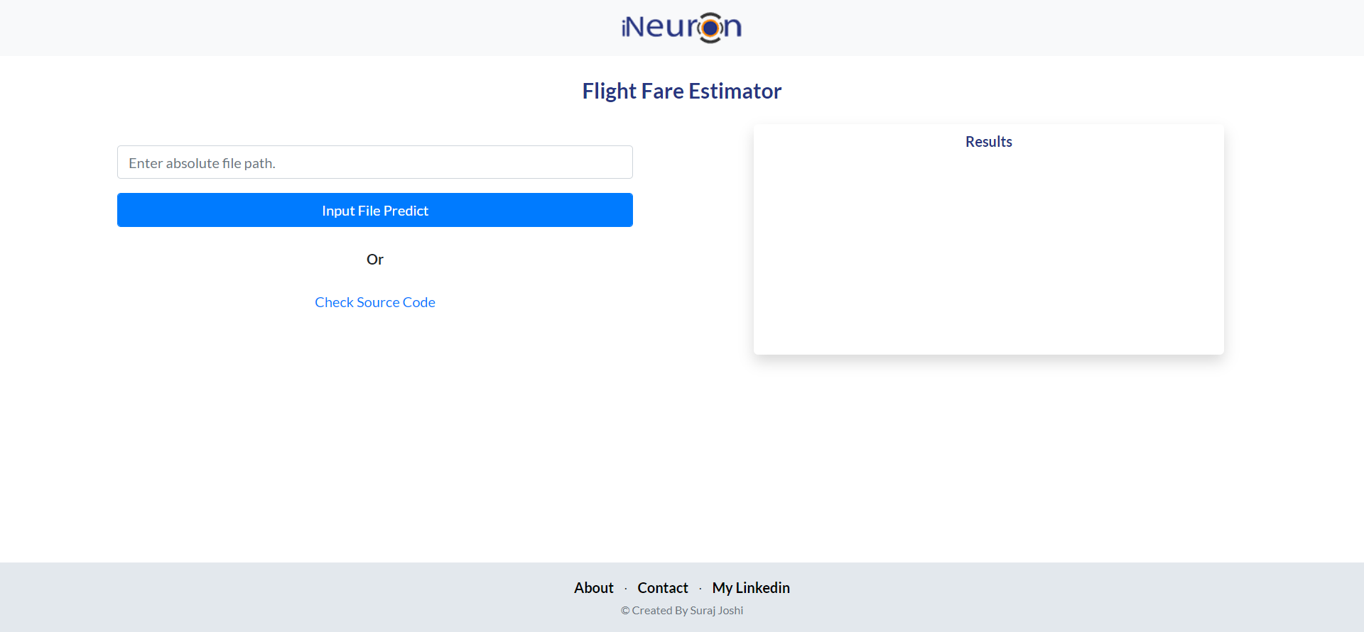

# 7. Conclusion

The Flight Fare prediction model will predict the fare of flight in prior so that costumer can get the idea of how much money they are going to spend on traveling.